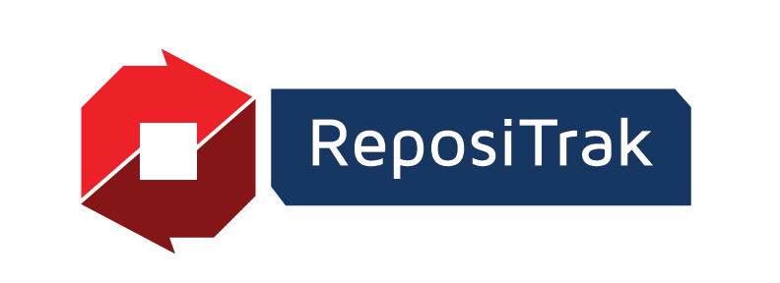

Supplier Logo

**PRESS RELEASE**

FOR IMMEDIATE RELEASE: Month XX, YYYY

**Media Contacts**

Derek Hannum

For ReposiTrak Sales Inquiries

435-645-2230

[dhannum@repositrak.com](mailto:dhannum@repositrak.com)

SUPPLIER CONTACT INFORMATION

For <COMPANY NAME> Media Inquiries

XXX-XXX-XXXX

EMAILADDRESS@COMPANY.COM

**COMPANY NAME Is Now “Traceability-Ready,” Sharing Accurate Traceability Data with Customers Through the ReposiTrak Traceability Network®**

*Tech-enabled solution enables the exchange of traceability data that meets the requirements of every customer’s traceability program*

**COMPANY CITY, STATE; Month XX, YYYY –** <COMPANY NAME> has been recognized as “Traceability-Ready” by the ReposiTrak Traceability Network®, meaning it can now share accurate and reliable traceability data with its retail, wholesale and foodservice customers.

ReposiTrak operates the largest network of food supply chain businesses using a shared platform for supply chain, food safety, and compliance management. The ReposiTrak Traceability Network is designed to be easy to use, cost-effective and scalable for businesses of all sizes. By joining the network, <COMPANY NAME> is helping its customers meet the requirements of the FDA’s Food Safety Modernization Act (FSMA) Section 204, which focuses on improving food traceability and safety.

“Food safety and regulatory compliance are top priorities for us,” said <COMPANY LEADER NAME AND TITLE>. “Joining the ReposiTrak Traceability Network and becoming Traceability-Ready allows us to provide our customers with accurate traceability data and strengthen trust throughout the supply chain.”

To earn the Traceability-Ready designation, <COMPANY NAME> worked closely with ReposiTrak to:

* Create and share traceability data files using customer-specific formats
* Ensure data accuracy using ReposiTrak’s 500+ point validation process
* Correct and improve data quality as needed to meet strict standards

The ReposiTrak Traceability Network also helps suppliers manage and share the Key Data Elements (KDEs) required by FSMA 204 when applicable, making compliance easier and more efficient.

“Being Traceability-Ready is a meaningful milestone and a competitive advantage for suppliers,” said Randy Fields, chairman and CEO of ReposiTrak. “It shows a supplier’s commitment to food safety, faster recalls and greater transparency. We encourage buyers across the industry to look for suppliers with this designation.”

ReposiTrak’s Traceability Network is currently the most widely adopted, easiest-to-use and most affordable traceability solution in the food industry.

Suppliers interested in the ReposiTrak Traceability Network can visit [ReposiTrak.com](https://repositrak.com/fda-food-traceability/traceability-for-suppliers/) or contact ReposiTrak Chief Customer Officer Derek Hannum ([DHannum@repositrak.com](mailto:DHannum@repositrak.com)).

**About <COMPANY>**

Company boilerplate statement

**About ReposiTrak**

ReposiTrak (NYSE: TRAK) provides retailers, suppliers, food manufacturers and wholesalers with a robust solution suite to help reduce risk and remain in compliance with regulatory requirements, enhance operational controls and increase sales with unrivaled brand protection. Consisting of three product families – food traceability, compliance and risk management and supply chain solutions – ReposiTrak’s integrated, cloud-based applications are supported by an unparalleled team of experts. For more information, please visit <https://repositrak.com>.

###